Thomas Short

CIS 260 | 11/13/2019

Get Set

Intersection

**Test Set Get Intersection:**

|  |  |  |  |
| --- | --- | --- | --- |
| **Input** | **Expect Output** | **Output** | **Rational** |
| Team one: Players 5  Jerseys: 1, 2, 3, 4, 5  Team two: players 8  Jerseys: 1, 2, 3, 4, 5, 6, 7, 8, | 1 2 3 4 5 | 1  2  3  4  5 | Two different length  Strings and only display the elements they have in common. |
|  |  |  |  |
|  |  |  |  |

**Get Intersection Result:**

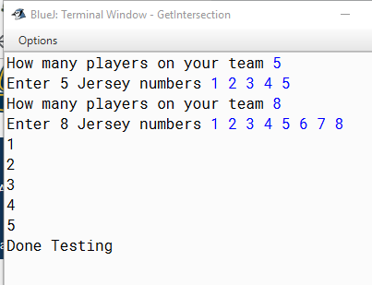

**Result with set size**

